Milan to Host More Than 1,200 Industry Leaders as Italy's Renewable Energy Market Faces a New Phase of Growth
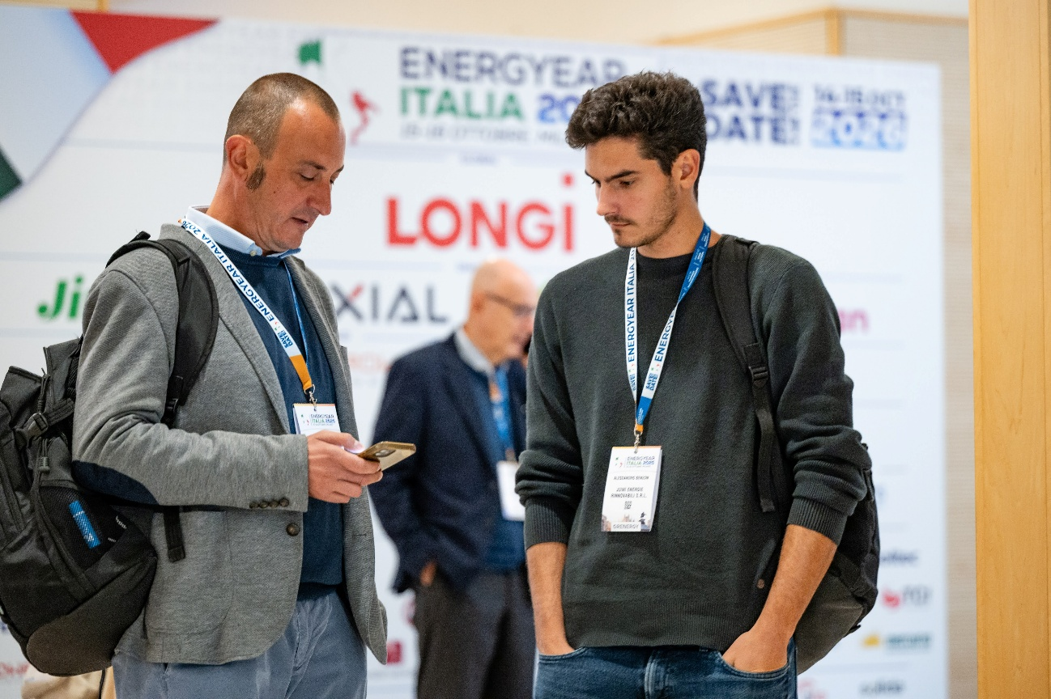
Madrid, 21 July 2026. The sixth edition of Energyear Italy will take place on 13–15 October at UNA HOTELS Expo Fiera Milano, bringing together more than 1,200 attendees, 100 partners, 120 speakers and over 20 conference sessions. Expanding to a three-day format for the first time, this year's event reflects the rapid evolution of the Italian renewable energy market while placing an even stronger focus on business networking and strategic partnerships.
The extended programme responds to growing demand from across the industry and will provide additional opportunities for developers, investors, utilities, EPC contractors, technology providers and financial institutions to exchange insights and explore new business opportunities.
Networking at the heart of the event
Networking will be one of the defining features of this year's edition. A combination of dedicated meeting areas and digital tools will enable participants to connect efficiently before, during and after the event.
Through the official event app, attendees will be able to browse the participant list, schedule one-to-one meetings and manage their agendas. A dedicated networking area featuring numbered meeting tables will facilitate 20-minute business meetings automatically assigned once both parties confirm their appointment.
The programme will also include permanent networking areas, workshops, private meeting rooms, seated lunches, networking cocktails and an exclusive VIP dinner for sponsors, creating an environment specifically designed to foster long-term business relationships across the renewable energy value chain.
Three days focused on the future of Italy's energy market
The conference agenda has been structured around three major themes that reflect the most pressing issues facing the Italian energy sector.
Day one will focus on renewable project development, covering permitting, grid access, utility-scale solar deployment, EPC execution, project bankability and technology competitiveness. Discussions will also explore agrivoltaics, engineering innovation and advanced solar design.
Day two will be dedicated to battery energy storage systems (BESS), addressing market opportunities, revenue models, hybrid projects, grid integration, monetisation strategies and the investment case for storage in Italy.
Day three will shift the focus to electricity demand, data centres and commercial & industrial consumers. Sessions will examine corporate PPAs, behind-the-meter solutions, digital energy management, artificial intelligence, energy optimisation and the growing role of flexible consumption in the energy transition.
Italy's energy transition continues to accelerate
The event comes at a time of significant transformation in the Italian electricity market. According to the latest data from transmission system operator Terna, renewable electricity generation increased by 27.8% in February 2026, driven primarily by wind power, while installed renewable capacity continues to expand across both solar and wind technologies.
As investment accelerates, Italy is emerging as one of Southern Europe's most dynamic renewable energy markets. At the same time, developers continue to face key challenges, including permitting procedures, grid constraints and the need for further investment in transmission infrastructure.
Against this backdrop, the conference will provide a platform for industry leaders to discuss market developments, regulatory evolution, financing strategies and the technologies shaping the next phase of Italy's energy transition.
About Energyear Italy
Energyear Italy is one of the country's leading renewable energy conferences, bringing together developers, investors, utilities, technology providers, financial institutions and policymakers to discuss market trends, foster strategic partnerships and support the growth of Italy's clean energy sector.

More information: https://energyear.com/en/italia/

Press Contact
Luis Montaño
Marketing & Communications
luis@energyear.com
+34 618 56 12 11

